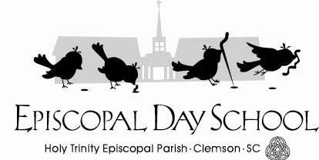
January 23, 2022

Dear Parents/Guardians,

This letter is to inform you that a student and/or staff member at EDS has a severe food allergy to peanuts/nuts. It is important that there is strict avoidance to this food in order to prevent a life-threatening allergic reaction. We need your help to provide the student/staff member with a safe school environment. Any exposure to peanuts/nuts may cause a life-- threatening allergic reaction that requires emergency medical treatment. To reduce the chance of this occurring, we require that you do not send any peanut or tree nut containing products to school when providing your child’s class snack or after school care snack. We also require that you do not pack peanut, peanut butter or tree nut products in your child’s lunch. I realize this request poses an inconvenience for you; and, I wish to express sincere appreciation for your support and understanding of this potentially life-threatening allergy. If your child has eaten peanuts/nuts before coming to school, please be sure your child’s hands and face have been thoroughly washed before entering the school. Please remember to do this for yourself, too, if you plan to visit in the classroom or join us on a field trip. We appreciate you following these procedures. Complete and return this form to acknowledge receipt and confirmation of this policy. Please contact me if you have any questions.

Stephanie LaGuardia, Episcopal Day School Director

…………………………………………………………………………………………………………………………………………………………………………….

Child’s Name:____________________________________________________________________
Print Parent/Guardian Name__________________________________________, I have read and understand the peanut/nut free school procedures. I will not send products containing peanuts or tree nuts in snacks or lunches. I agree to do my part in keeping Holy Trinity Episcopal Day School peanut/nut free.
Parent’s/Guardian’s Signature _____________________________ Date____________

